

GL BAJAJ INSTITUTE OF TECHNOLOGY AND MANAGEMENT, GREATER NOIDA

“PRACTICALS”
ON
IT SKILL
TOWARDS THE PARTIAL FULLFILLMENT FOR THE AWARD OF DEGREE OF
MASTERS OF BUSINESS ADMINISTRATION (BA)

(Dr. A.P.J. Abdul Kalam Technical University, Lucknow, Uttar Pradesh)

By
NAMAN SINGH CHAUHAN
SEC-J
Admission No.- 25162CN108
Session 2025-26
Under the Supervision of
Mr. Vijay Kumar Singh

Practical No. Table of Content |  | Signature
Practical 1 | To create and design Admission/Enquiry Forms in MS Word.
Practical 2 | To Design E-Book cover page/Book from/back page in MS Word.
Practical 3 | To create business card using shapes, text, and colour in MS Word.
Practical 4 | To use smart art and create organization chart in MS Word.
Practical 5 | To make book content page and index page in MS Word.
Practical 6 | To insert image into the shape in MS Word.
Practical 7 | To create a chart and show the products price combination between  2015,2016,2017and 2018 in MS Word.
Practical 8 | To Create letterhead, identify card of any company and institution that you got and insert the watermark with that company name in MS Word.
Practical 9 | To decorate word document with page border, content border add pattern and write beautiful text in MS Word.
Practical 10 | To write 10 lines or 10 sentences and then change the font colour, style and size of each sentence. Make each one different than previous and next.
Practical 11 | To enter the data given, get the percentage of all the figures within the range in MS EXCEL.
Practical 12 | To enter the data given, Archive Target in Percentage of all the figures within the range in MS EXCEL.
Practical 13 | To enter the data given and use COUNT Statement of all the figures within the range in MS EXCEL.
Practical 14 | To enter the data given and use COUNTIF Statement of all the figures within the range in MS EXCEL.
Practical 15 | To enter the data given and use COUNTIFS Statement of all the figures within the range in MS EXCEL.
Practical 16 | TO illustrate the use of Macros in MS word.
Practical 17 | How to insert hyperlink in MS Word.
Practical 18 | Demonstrate the use of mail merge in MS word.
Practical 19 | To use the given data to get sum of all the figures within the range in MS Excel.
Practical 20 | To enter the data given, get the sum of all the figures within the range in MS EXCEL.
Practical 21 | Using the formula given in the table below, calculate the amount payable and total amount payable by the company to the employees.
Practical 22 | On the occasion of Children Day, school decided to distribute toffees to all the students. Calculate the total no. of toffees each student will get from the given data in MS Excel.
Practical 23 | To use the given data to calculate the achieved target of employees by subtraction
Practical 24 | To enter the data given and use SUM Statement of all the figures within the range in MS EXCEL
Practical 25 | To enter the data given and use SUMIF Statement of all the figures within the range in MS EXCEL.
Practical 26 | To enter the data given and use SUMIFS Statement of all the figures within the range in MS EXCEL.
Practical 27 | To enter the data given and create a monthly salary slip of all the figures within the range in MS EXCEL.
Practical 28 | To enter the data given and use VLOOKUP Statement of all the figures within the range in MS EXCEL.
Practical 29 | To enter the data given and create a Payroll of all the figures within the range in MS EXCEL.
Practical 30 | To enter the data given and create a income and expenses projection of all the figures within the range in MS EXCEL.
Practical 31 | To enter the data given and create a profit and loss account of all the figures within the range in MS EXCEL.

PRACTICAL-01
OBJECTIVE: To create and design Admission/Enquiry Forms in MS Word.

STEP 1: MS Word
AFFIX a recent passport size photo
STEP 2: Write and make the form, insert table

RANA'S PUBLIC SCHOOL
ADMISSION FORM SESSION 2023-24

- Name of the Student
………………………………………………………………………………………………………………………………………………
(First Name) (Middle Name) (Surname)
- Class to which admission is sought: ……………………………………………………………………………………….
(Standard 1 to 10) / XI/XII (Commerce/Science)
- Father's Name: ……………………………………………………………………………………………………………………….
- Mother's Name: …………………………………………………………………………………………………………………….
- Residential address and phone no.: ……………………………………………………………………………………….
……………………………………………………………………………………………………………………………………………….
Phone: ………………………………………………. Email: ……………………………………………………………………….
- Occupation of Parents/Guardian: …………………………………………………………………………………………..
- Religion/Caste/Sub Caste: ………………………………………………………………………………………………………
- Whether SC/ST/NT/OBC: ………………………………………………………………………………………………………..
- Sex: Male/Female
- Date of birth: ………………………………………………………………………………………………………………………….
- Place of birth: …………………………………………………………………………………………………………………………
- Name of the school last attended: ………………………………………………………………………………………….
- Number and date of school leaving certificate: ………………………………………………………………………
- Provide details if child is differently abled/allergic to any allergen: …………………………………………
- Blood Group of the child: …………………………. Aadhaar No.: …………………………………………………..

Details Of Examinations Passed:
Exam Passed | Month & Year | Roll No. | Board | Subject | Marks/Grade Secured | Max. Marks | % of mark/Grade (total)

DATE:PLACE: (Signature of the Student) (Signature of Parents/Guardians) Page 1

PRACTICAL-02
OBJECTIVE: To Design E-Book cover page/Book from/back page in MS Word.

STEP 1: Open MS Word
STEP 2: Click insert> insert cover page.
  IT PRATICAL FILE  LAB 1 | Abstract  Nandeshwar Kumar  PROJECT MAKER

PRACTICAL-03
OBJECTIVE: To create business card using shapes, text, and colour in MS Word.

STEP 1: MS Word
STEP 2: Click on insert option.
STEP 3: Click on shape> insert shape> edit it according to yourself.

GUPTA’S PUBLIC SCHOOL
KNOWLEDGE PARK, GREATER NOIDA, (U.P.)

Mr. Nandeshwar Gupta
(Owner)

Phone: + 9508454284 Email: nandeshwarkumar46@gmail.com

PRACTICAL-04
OBJECTIVE: To use smart art and create organization chart in MS Word.

STEP 1: Open MS Word
STEP 2: Click on insert option.
STEP 3: Click the smart art > select the chart >edit.

PRACTICAL-05
OBJECTIVE: To make book content page and index page in MS Word.

STEP 1: MS Word
STEP 2: Click in insert option.
STEP 3: Click on Table option.

Chapters | Table of contents | Page No.
1. | COVER PAGE | 1
2. | CERTIFICATE OF COMLETITION | 2-5
3. | ACKNOWLEDGEMENT | 6-8
4. | TABLE OF CONTENT | 9-12
5. | INTRODUCTION | 13-17
6. | NEED FOR THE STUDY | 18-20
7. | SIGN AND SYMPTOMS | 21-24
8. | MATERIAL/PREGNANCY | 25-27
9. | NUTRITION DURING PREGNANCY | 28-31
10. | EXERCISE DURING PREGNANCY | 32-35
11. | MEDITATION DURING PREGNANCY | 36-37
12. | SLEEP DURIND PREGNANCY | 38-41
13. | DENTAL CARE DURING PREGNANCY | 42-45
14. | LITERATURE REVIEW | 46-48
15. | DEPRESSION | 49-52
16. | MATERNAL DEPRESSION | 52-55
17. | ANXIETY | 56-59
18. | MATERNAL ANXIETY | 60-64
19. | SHARED CARE MODEL OF HEALTHCARE | 65-67
20. | UNIT SUMMARY | 68-74
21. | METHODOLOGY OF RESEARCH | 75-79
22. | VARIABLES OF THE STUDY | 80-87
23. | SETTING OF THE STUDY | 88-95

PRACTICAL-06
OBJECTIVE: To insert image into the shape in MS Word.

STEP 1: MS Word
STEP 2: Click on insert option.
STEP 3: Click on picture.
STEP 4: Click on picture shape> choose the picture shape.


PRACTICAL 07
OBJECTIVE: To create a chart and show the products price combination between
2015,2016,2017and 2018 in MS Word.

STEP 1: MS Word
STEP 2: Click on insert option
STEP 3: Click on chart > insert the type of chart
STEP 4: Fill the chart data on the excel sheet.

PRACTICAL-08
OBJECTIVE: To Create letterhead, identify card of any company and institution that you got and insert the watermark with that company name in MS Word.
STEP 1: MS Word
STEP 2: Click on insert option.
STEP 3: Create a letterhead using shape and art.
STEP 4: Click on page layout > insert page border.
GSTIN No. 00987YH776833149 Phone: +91 9508454284
GUPTA’s PUBLIC SCHOOL
KNOWLEDGE PARK, GREATER NOIDA (U.P)

Serial No.: 01 Date: 03/11/2025

NANDESHWAR kUMAR

PRACTICAL-09
OBJECTIVE: To decorate word document with page border, content border add pattern and write beautiful text in MS Word.
STEP 1: MS Word.
STEP 2: Click on design > select page border and page colour.
STEP 3: Click on insert > select shapes and add
ACCOUNTING

Accounting is an art of recording, classifying and summarising in a significant manner and in term of money, transaction and events which are in part of at least of a financial character and interpreting the result there out

PRACTICAL-10
OBJECTIVE: To write 10 lines or 10 sentences and then change the font colour, style and size of each sentence. Make each one different than previous and next.
STEP 1: MS Word.
STEP 2: Write down 10 lines
STEP 3: Select the desired text and click on home > select the font size.
STEP 4: Select the styles and colour given in home tab.

1) SUCCESS CAN BE REGARDED AS A MEASURE OF HOW MUCH SATISFIED AND HAPPY YOU ARE IN YOUR LIFE.

2) Success doesn't have any timeline it it doesn't matter what you were in past, it matters what you are in present.

3) The way to success is not a straight one; it has lots of twists and turns and sometimes U-turn in the life of an individual.

4) In order to become successful in your life, first of all you have to set your goals: those things which will help you in achieving success.

5) MAKE A LIST OF DREAMS AND YOUR WISHES THAT YOU WANT TO FULFIL IN VARIOUS AREAS OF YOUR LIFE.

6) Now focus on one goal only and try to achieve it then move on to another and so on.

7) Now determine your ability to achieve your goals and assess whether you will be able to achieve it or not.

8) There will be a moment when the plan you have made to achieve your goal will not work, then the time has come to change your strategy for achieving it.

9) Goals are nothing but an analysis of your strengths and weaknesses, as different goal will require different approach.
10) Exploring your abilities, improving them and developing yourself is another method to achieve success.

PRACTICAL-11
OBJECTIVE: To enter the data given, get the percentage of all the figures within the range in MS EXCEL.

Name | Subject | Max Marks | Marks Obt.
Nandeshwar Kumar | Account | 100 | 0
Akshay Kumar | Account | 100 | 85
Prashant Kumar | Account | 100 | 80
Rahul Kumar | Account | 100 | 60
Vikash Kumar | Account | 100 | 65
Saurav Kumar | Account | 100 | 70
Shivangi Kumari | Account | 100 | 65
Raj Kumar | Account | 100 | 65
Manish Kumar | Account | 100 | 65
 |  | Total | 555
 |  | Total | 555
 | Subtraction |  | 470
 | Multiplication |  | 6800
 | Division |  | 0.705882353
 | Percentage |  | 85
 | Percentage |  | 555
 | Percentage |  | 100
 | Percentage |  | 85

PRACTICAL-12
OBJECTIVE: To enter the data given, Archive Target in Percentage of all the figures within the range in MS EXCEL.

Employee Name | Sales Amount | Target Amount | Archive Target In Percentage
Rahul | 28800 | 25000 | 86.80555556
Raj | 42500 | 20000 | 47.05882353
Akshay | 44400 | 20000 | 45.04504505
Vikash | 30800 | 10000 | 32.46753247
Kundan | 16900 | 15000 | 88.75739645
Vishal | 10200 | 10000 | 98.03921569
Mohit | 19800 | 15000 | 75.75757576
Saurav | 18500 | 15000 | 81.08108108
Rohan | 14400 | 10000 | 69.44444444
Shahil | 13200 | 10000 | 75.75757576
Vinay | 17900 | 15000 | 83.79888268

PRACTICAL-13
OBJECTIVE: To enter the data given and use COUNT Statement of all the figures within the range in MS EXCEL.

Name | Salary
Nandeshwar Kumar | 90000
Akshay Kumar | 50000
Anish Kumar | 5000
Nandeshwar Kumar | 8000
Anuraj Kumar | 40000
Vikash Kumar | 60000
Rahul Kumar | 70000
Rohit Kumar | 80000
Rohan Kumar | 50000
FORMULA | =COUNT(B3:B11)
COUNT: | 9

PRACTICAL-14
OBJECTIVE: To enter the data given and use COUNTIF Statement of all the figures within the range in MS EXCEL.

Name | Salary
Nandeshwar Kumar | 90000
Akshay Kumar | 50000
Anish Kumar | 5000
Nandeshwar Kumar | 8000
Anuraj Kumar | 40000
Vikash Kumar | 60000
Rahul Kumar | 70000
Rohit Kumar | 80000
Rohan Kumar | 50000
FORMULA | =COUNTIF(B3:B11,">5000")
COUNTIF: | 8

PRACTICAL-15
OBJECTIVE: To enter the data given and use COUNTIFS Statement of all the figures within the range in MS EXCEL.

Name | Salary
Nandeshwar Kumar | 90000
Akshay Kumar | 50000
Anish Kumar | 5000
Nandeshwar Kumar | 8000
Anuraj Kumar | 40000
Vikash Kumar | 60000
Rahul Kumar | 70000
Rohit Kumar | 80000
Rohan Kumar | 50000
FORMULA | =COUNTIFS(B3:B11,">10000",A3:A11,"Nandeshwar Kumar")
COUNTIFS: | 1

PRACTICAL- 16
OBJECTIVES: TO illustrate the use of Macros in MS word.
Step1: open MS word.
Step2: go to view.
Step3: select micros and assign a shortcut key.
Step4: record data.

Name: Rohan
Father's Name: Shyam
Mother's name: Kiran
Age: 20
DOB:05/09/25

Name:
Father's Name:
Mother's name:
Age:
DOB:

PRACTICAL-17
OBJECTIVES: How to insert hyperlink in MS Word.

Step1: open MS word
Step2: Go to insert
Step3: select link. Then insert link

GL Bajaj

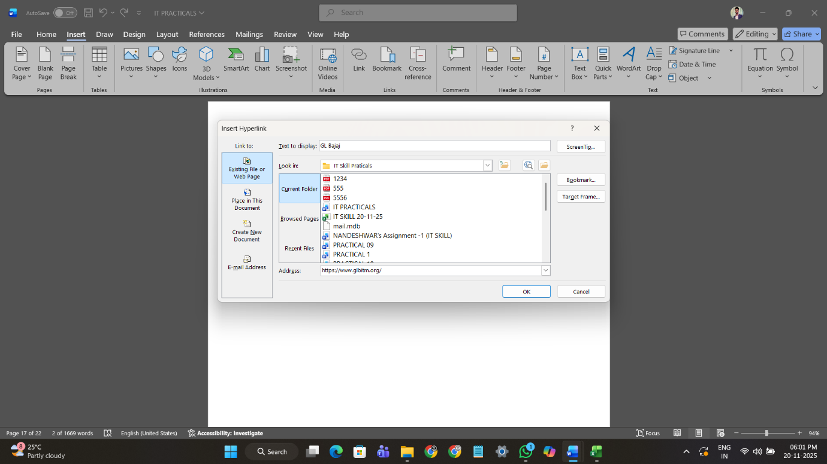

PRACTICAL-18
OBJECTIVES: Demonstrate the use of mail merge in MS word.

STEP 1: open MS word
STEP 2: Write an application
STEP 3: select mailing
STEP 4: select recipients then write preview

To
The Head of Department (MBA)
GL BAJAJ
Noida
Subject: Request for leave for 2 days.
Respected Sir/Madam,
I humbly wish to bring to your notice that I am a student of [Your Class/Semester, Roll No. 377 of your department. I would like to request you for leave for 2 days because I am going to out of the city. Kindly consider my request and grant me approval for the same. I shall be grateful to you.

Thanking you,
Yours sincerely,
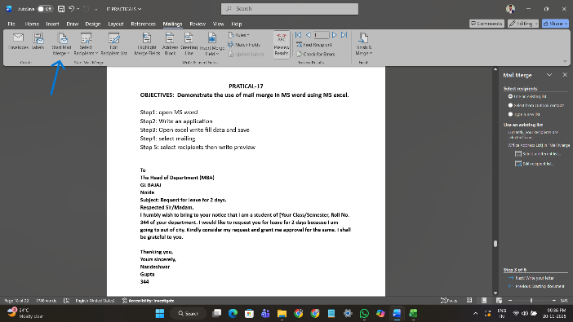
Anish
Kumar
377
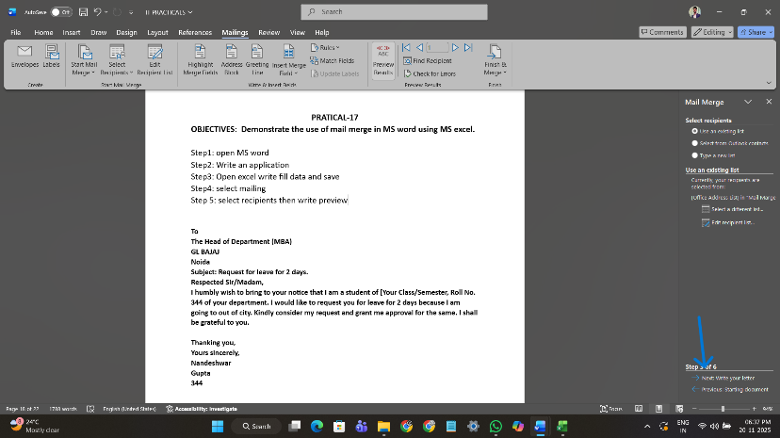

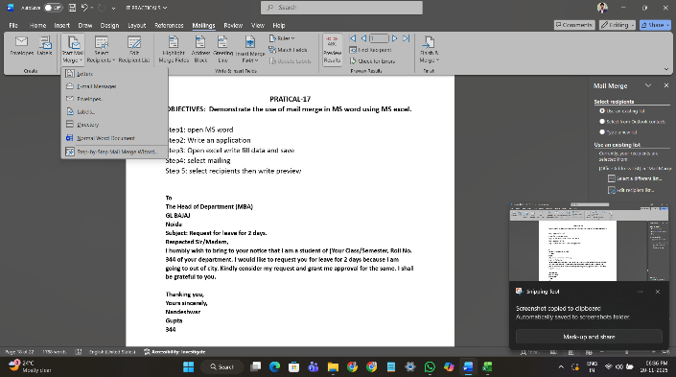

IT SKILL LAB-1 (BMBA151) NANDESHWAR KUMAR (MBA 23479)

PRACTICAL-19
OBJECTIVE: To use the given data to get sum of all the figures within the range in MS Excel.

FOOD | Monday | Tuesday | Wednesday | Thursday | Friday | Total
Breakfast | 3560 | 3186 | 2952 | 3395 | 3436
Lunch | 20163 | 21416 | 19912 | 19681 | 18628
Snacks | 9873 | 12172 | 12642 | 12711 | 18846
Dinner | 2405 | 3544 | 2694 | 3120 | 3712
 |  |  |  | GRAND TOTAL

STEP 1: Open MS Excel.
STEP 2: Copy the question and calculate the sum of the following table by using formula
FORMULA USED: SUM TOTAL IS = SUM(VALUE1:VALUE2) OR YOU CAN WRITE THE FORMULA AND SELECT THE VALUE YOU WANT TO ADD.
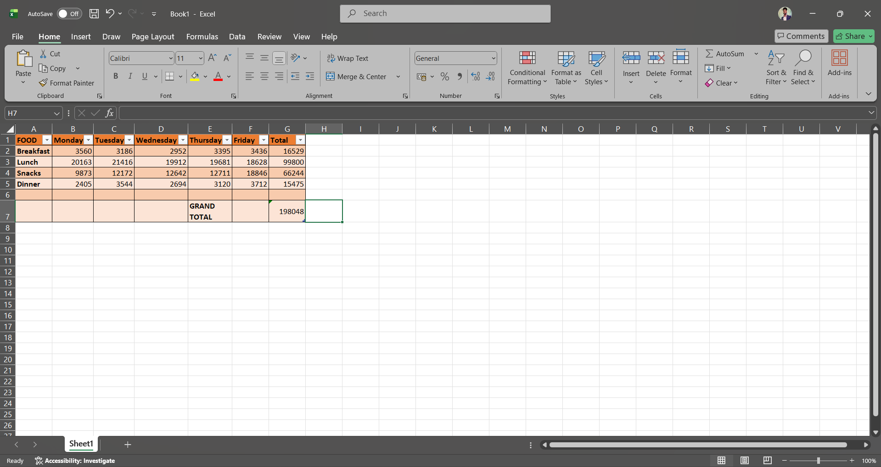

IT SKILL LAB-1 (BMBA151) NANDESHWAR GUPTA (MBA 23479)

PRACTICAL-20
OBJECTIVE: To enter the data given, get the sum of all the figures within the range in MS EXCEL.

- Calculate the total for each sales person and get the grand total
- Format the worksheet as follows:
Make all the total bold, two decimal places, comma, Centre the title across column A-E and make it size 16, Bold, Italic.
- Put a double border round the whole table and a single line border inside the table.
- Save the worksheet as stationary analysis.
GUPTA'S STATIONARY SUPPLIERS LTD.
DATE | SALESPERSON | ITEMS | RECIPT No. | VALUE
21-Nov | AYAZ | TOYS | 1238 | 1782.1
26-Nov | AYAZ | STATIONARY | 1255 | 4853.55
26-Nov | AYAZ | TOYS | 1395 | 51.35
 |  |  | AYAZ'S TOTAL | 6687
21-Nov | BHOOMIKA | CARDS | 1141 | 91.15
21-Nov | BHOOMIKA | BOOKS | 1982 | 442.6
24-Nov | BHOOMIKA | TOYS | 1885 | 561.5
26-Nov | BHOOMIKA | TOYS | 1875 | 62.75
 |  |  | BHOOMIKA'S TOTAL | 1158
22-Nov | AYUSHI | BOOKS | 1032 | 234.5
26-Nov | AYUSHI | SPORTS GOODS | 1920 | 472.6
 |  |  | AYUSHI'S TOTAL | 707.1
25-Nov | ANUSHI | TOYS | 1774 | 364.15
 |  |  | AYUSHI'S TOTAL | 364.15
22-Nov | AKRUTI | ELECTRICITY | 1160 | 52.95
23-Nov | AKRUTI | CARDS | 1075 | 81.6
23-Nov | AKRUTI | OTHERS | 1745 | 132.95
24-Nov | AKRUTI | SPORTS GOODS | 1662 | 2580.1
 |  |  | AKRUTI'S TOTAL | 2847.6
 |  |  | GRAND TOTAL | 11763.85

PRACTICAL – 21
OBJECTIVE: Using the formula given in the table below, calculate the amount payable and total amount payable by the company to the employees.

SERVICE COMPANY DETAILS
OVER TIME DETAILS
Date | Name | Hours Worked | Rate | Amount
26-Nov | Nandeshwar | 5 | 70
26-Nov | Akshay | 5 | 100
26-Nov | Anish | 5 | 100
26-Nov | Prashant | 4 | 100
30-Nov | Nishant | 3 | 100
30-Nov | Rahul | 6 | 70
30-Nov | Niket | 5 | 100
30-Nov | Harsh | 4 | 70
30-Nov | Mohan | 5 | 100
30-Nov | Sohan | 5 | 100
02-Dec | Lalit | 4 | 70
 |  | Total Amount

STEP 1: Open MS Excel and Copy the Question.
STEP 2: Add the value by using formula.
FORMULA USED: FOR MULTIPLICATION = (VALUE1*VALUE2)
FOR TOTAL AMOUNT= Sum (Select all the amount cell).
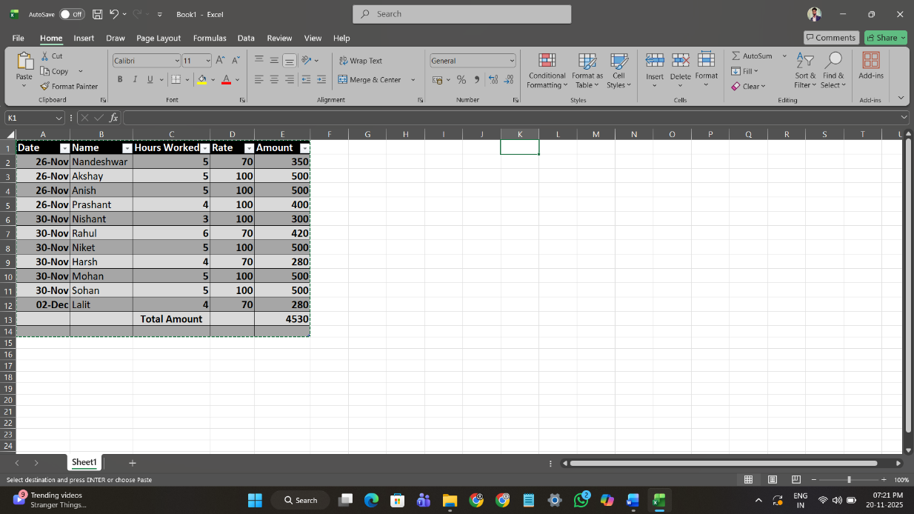

PRACTICAL-22
OBJECTIVE: On the occasion of Children Day, school decided to distribute toffees to all the students. Calculate the total no. of toffees each student will get from the given data in MS Excel.

GUPT’S PUBLIC SCHOOL
STUDENT | Total No. Of Toffees | Total No. Of Student | No. Of Toffees each student will get
Class 1 | 200 | 40
Class 2 | 144 | 72
Class 3 | 165 | 55
Class 4 | 136 | 68
Class 5 | 148 | 74

STEP 1: Open MS Excel and copy the question.
STEP 2: Calculate total no. of toffees each student will get by using formula.
Formula for Division - =(No. of toffees/No. of students)

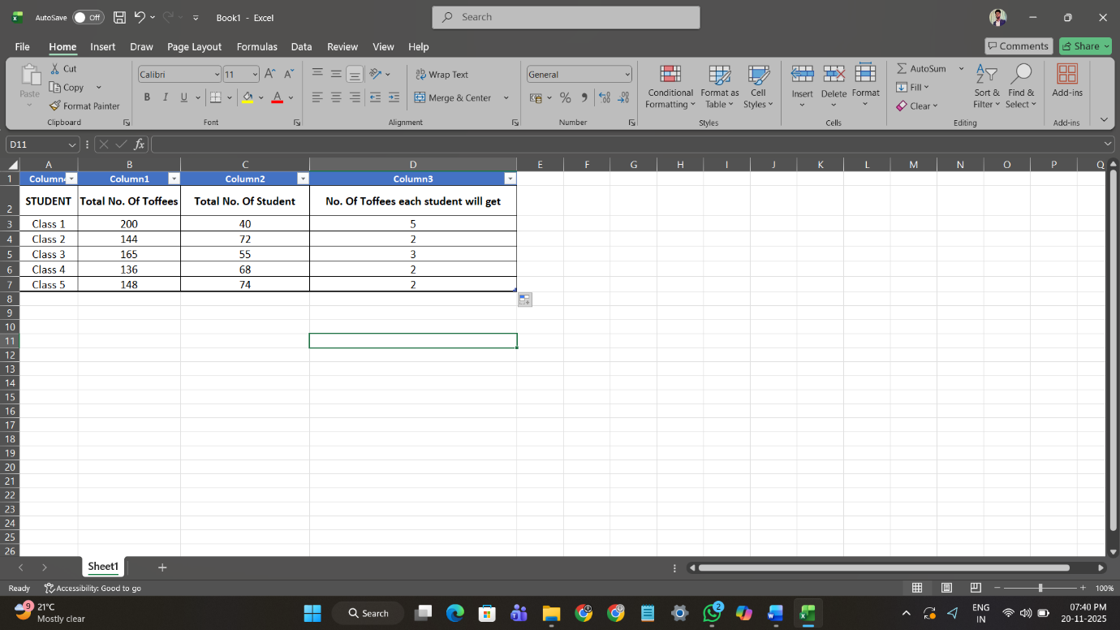

PRACTICAL-23
OBJECTIVE: To use the given data to calculate the achieved target of employees by subtraction.
Employee Name | Sales Amount | Target Amount | Achieved Target
Nandeshwar Kumar | 28800 | 25000 | 3800
Akshay Kumar | 22500 | 20000 | 2500
Rahul Kumar | 24440 | 20000 | 4440
Raj Kumar | 13800 | 10000 | 3800
Prashant Kumar | 16900 | 15000 | 1900
Prabhat Kumar | 10200 | 10000 | 200
Rohit Kumar | 19800 | 15000 | 4800
Anish Kumar | 18500 | 15000 | 3500
Nishant Kumar | 14400 | 10000 | 4400
Mohan Kumar | 13200 | 10000 | 3200
GRAND TOTAL OF ACHIEVED TARGET |  |  | 32540

STEP 1: Open MS Excel and copy the table.
STEP 2: Calculate the achieved target by using formula.
FOR SUBTRACTION = (Sales Amount-Target Amount)
For GRANE TOTAL OF ACHIEVED TARGET=SUM/Select all the achieved target cells)
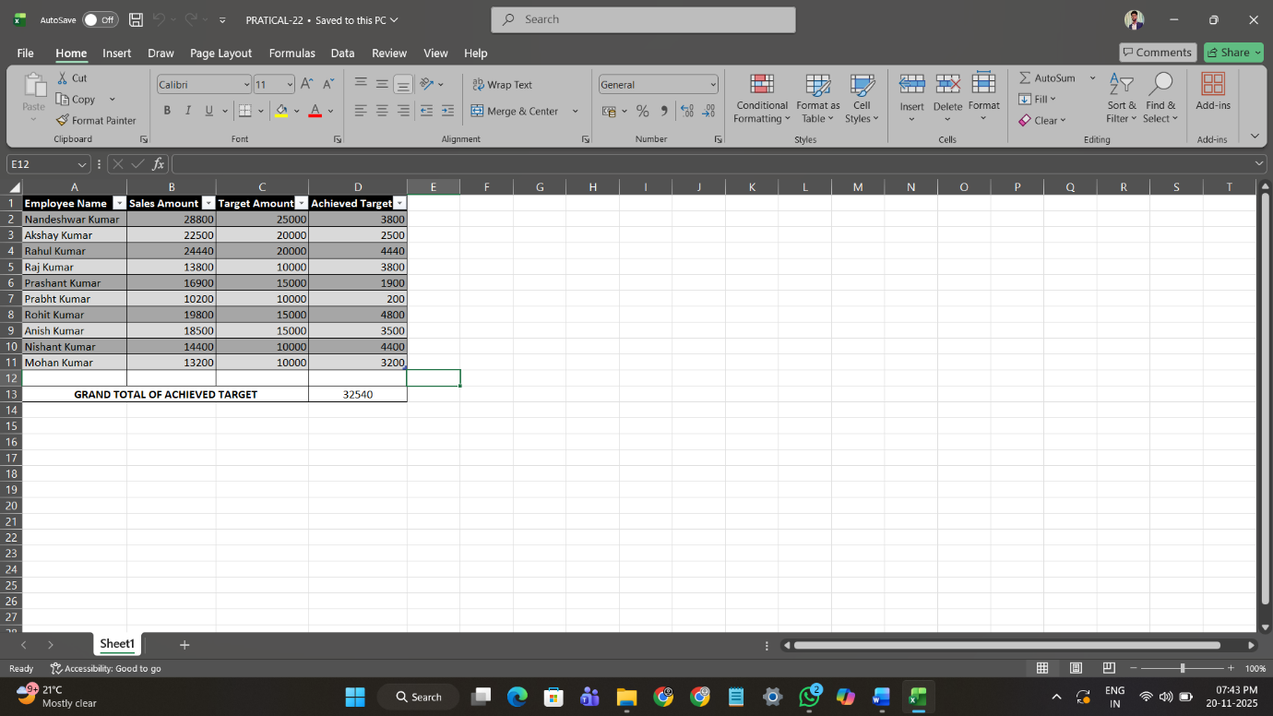
PRACTICAL-24
OBJECTIVE: To enter the data given and use SUM Statement of all the figures within the range in MS EXCEL.

Employee Name | State | Product | Amount
Nandeshwar Kumar | Bihar | Toys | 5100
Anish Kumar | West Bengal | Soap | 2000
Prashant Kumar | Delhi | Television | 50000
Akshay Kumar | Goa | Television | 50000
Rohit Kumar | Bihar | Oil | 2000
Rohan Kumar | West Bengal | Toys | 5000
Mohit Kumar | Delhi | Soap | 2000
Prashant Kumar | Goa | Remote | 500
Aman Kumar | Bihar | Television | 50000
Raj | West Bengal | Oil | 500
Manish | Delhi | Toys | 5000
Saurav | Goa | Soap | 2000
Sourabh | Bihar | Remote | 6000
Vikash Kumar | West Bengal | Television | 50000
Vijay Kumar | Delhi | Oil | 5000
 |  | Total | 235100

Formula: =SUM(D2:D16)

PRACTICAL-25
OBJECTIVE: To enter the data given and use SUMIF Statement of all the figures within the range in MS EXCEL.

Employee Name | State | Product | Amount
Nandeshwar Kumar | Bihar | Toys | 5100
Anish Kumar | West Bengal | Soap | 2000
Prashant Kumar | Delhi | Television | 50000
Akshay Kumar | Goa | Television | 50000
Rohit Kumar | Bihar | Oil | 2000
Rohan Kumar | West Bengal | Toys | 5000
Mohit Kumar | Delhi | Soap | 2000
Prashant Kumar | Goa | Remote | 500
Aman Kumar | Bihar | Television | 50000
Raj | West Bengal | Oil | 500
Manish | Delhi | Toys | 5000
Saurav | Goa | Soap | 2000
Sourabh | Bihar | Remote | 6000
Vikash Kumar | West Bengal | Television | 50000
Vijay Kumar | Delhi | Oil | 5000
 |  | Total's Television | 200000

Formula: = SUMIF(C2:C16,"Television",D2:D16)

PRACTICAL-26
OBJECTIVE: To enter the data given and use SUMIFS Statement of all the figures within the range in MS EXCEL.

Employee Name | State | Product | Amount
Nandeshwar Kumar | Bihar | Toys | 5100
Anish Kumar | West Bengal | Soap | 2000
Prashant Kumar | Delhi | Television | 50000
Akshay Kumar | Goa | Television | 50000
Rohit Kumar | Bihar | Oil | 2000
Rohan Kumar | West Bengal | Toys | 5000
Mohit Kumar | Delhi | Soap | 2000
Prashant Kumar | Goa | Remote | 500
Aman Kumar | Bihar | Television | 50000
Raj | West Bengal | Oil | 500
Manish | Delhi | Toys | 5000
Saurav | Goa | Soap | 2000
Sourabh | Bihar | Remote | 6000
Vikash Kumar | West Bengal | Television | 50000
Vijay Kumar | Delhi | Oil | 5000
 |  | Total's Television by State Delhi | 50000

Formula: =SUMIFS(D2:D16,C2:C16,"Television",B2:B16,"Delhi")

PRACTICAL-27
OBJECTIVE: To enter the data given and create a monthly salary slip of all the figures within the range in MS EXCEL.

Flex Industries Pvt. Ltd.
Block-D, Sector-44, Noida Uttar Pradesh-201303
Monthly Salary Slip
Employee ID | A105 | Employee Name | Deepak
Designation | Marketing Manager | Month & Year | Dec-2022
Earnings |  | Deductions
Basic | 11500 | Provident Fund | 1150
Overtime | 4200 | E.S.I. | 230
Conveyance | 300 | Loan | 0
Extra Income | 0 | Tax | 0
Total Addition | 16000 | Total Deduction | 1380
 |  | Net Salary | 14620
Signature of the Employee _____________ |  | Director __________________________

Employee ID | Employee Name | Designation | Month & Year | Basic | Overtime Amt. | Conveyance | Provident Fund | E.S.I.
A101 | Gaurav Singh | CEO | Dec-2022 | 12000 | 5000 | 550 | 1200 | 240
A102 | Deepu | General Manager | Dec-2022 | 11000 | 3000 | 500 | 1100 | 220
A103 | Anshika Agarwal | Sales Manager | Dec-2022 | 10000 | 5500 | 500 | 1000 | 200
A104 | Chelsy | HR | Dec-2022 | 12000 | 4500 | 500 | 1200 | 240
A105 | Deepak | Marketing Manager | Dec-2022 | 11500 | 4200 | 300 | 1150 | 230
A106 | Anupam Singh | Finance Manager | Dec-2022 | 8000 | 2500 | 300 | 800 | 160
A107 | Aryan | Production Manager | Dec-2022 | 7000 | 3000 | 450 | 700 | 140
A108 | Ankita Soni | ASM | Dec-2022 | 7500 | 3500 | 500 | 750 | 150
A109 | Aastha Rawat | G.M. East | Dec-2022 | 8000 | 3000 | 550 | 800 | 160
A110 | Arti Kumari | G.M. West | Dec-2022 | 6000 | 2000 | 550 | 600 | 120

PRACTICAL-28
OBJECTIVE: To enter the data given and use VLOOKUP Statement of all the figures within the range in MS EXCEL.

Employee Name | Department | Salary
Nandeshwar Kumar | HR | 50000
Vishal Kumar | Sales | 60000
Akshay Kumar | Marketing | 9000
Anish Kumar | HR | 50000
Prashant Kumar | Sales | 60000
Mohan Kumar | Marketing | 80000
Roan Kumar | HR | 40000
Rohit Kumar | Sales | 60000
Naman Kumar | Marketing | 55000
 | 80000
 | Sales
 | Marketing

SALES =VLOOKUP(A6,A2:C10,2,0)
MARKETING =VLOOKUP("Mohan Kumar",A2:C10,2,0)

PRACTICAL-29
OBJECTIVE: To enter the data given and create a Payroll of all the figures within the range in MS EXCEL.

 |  | PAYROLL
emp-code | date of joining | deparetment | basic | DA | T.A | house (yes/no) | HRA | gross | P.F | P.TAX | net
EC/001 | 10-04-2006 | SALES | 25000 | 10000 | 7500 | NO | 3750 | 46250 | 3125 | 200 | 42925
EC/002 | 01-02-2004 | AUDIT | 14000 | 5600 | 4200 | YES | 0 | 23800 | 1750 | 100 | 21950
EC/003 | 08-05-2007 | MEDIA | 8000 | 3200 | 2400 | NO | 1200 | 14800 | 1000 | 80 | 13720
EC/004 | 02-02-2008 | SALES | 18000 | 7200 | 5400 | NO | 2700 | 33300 | 2250 | 150 | 30900
EC/005 | 12-06-2009 | ADMIN | 9000 | 3600 | 2700 | NO | 1350 | 16650 | 1125 | 80 | 15445
EC/006 | 20-08-2008 | ACCT | 4000 | 1600 | 1500 | NO | 600 | 7700 | 500 | 0 | 7200
EC/007 | 10-05-2010 | MEDIA | 16000 | 6400 | 4800 | NO | 2400 | 29600 | 2000 | 150 | 27450
EC/008 | 10-04-2006 | SALES | 19000 | 7600 | 5700 | NO | 2850 | 35150 | 2375 | 150 | 32625
EC/009 | 02-04-2010 | ACCT | 8000 | 3200 | 2400 | NO | 1200 | 14800 | 1000 | 80 | 13720
EC/010 | 15-06-2010 | AUDIT | 12000 | 4800 | 3600 | YES | 0 | 20400 | 1500 | 100 | 18800

P.TAX=IF(E10<5000,"0",IF(AND(E10>5000,E10<6000),"60",IF(AND(E10>6000,E10<10000),"80",IF(AND(E10>10000,E10<15000),"100",IF(AND(E10>15000,E10<20000),"150",IF(E10>20000,"200"))))))

PRACTICAL-30
OBJECTIVE: To enter the data given and create a income and expenses projection of all the figures within the range in MS EXCEL.

INCOME AND EXPENSES PROJECTION
YEAR | 1999 | 2000 | 2001 | 2002 | 2003 | 2004
SALES | 10000 | 11000 | 13200 | 17160 | 24024 | 36036
% Growth over the prevision year | 10% | 20% | 30% | 40% | 50% | 60%
Sales growth is RS | 1000 | 2200 | 3960 | 6864 | 12012 | 21621.6
Total new sales + sales growth projection in RS. | 11000 | 13200 | 17160 | 24024 | 36036 | 57657.6
Materials | 1100 | 2640 | 5148 | 9609.6 | 18018 | 34594.56
Wages | 1100 | 2640 | 5148 | 9609.6 | 18018 | 34594.56
Other benefits
Other Income
Salary : Office
Salary : Sales
Miscellaneous benefits
Advertising and Promotion
Miscellaneous income
Interest on lone
Pre- Tax income | 13200 | 18480 | 27456 | 43243.2 | 72072 | 126846.72
Tax (28% of Pre- Tax income) | 3696 | 5174.4 | 7687.68 | 12108.096 | 20180.16 | 35517.0816

PRACTICAL-31
OBJECTIVE: To enter the data given and create a profit and loss account of all the figures within the range in MS EXCEL.

Details | Amount
Rent | 500
Salary | 2000
Gross Profit | 1000
Interest Received | 1000
Commission Paid | 2000
Commission Received | 1500
Discount Received | 2500
Discount Paid | 3000
Advertisement | 1000
Bad Debts | 3500

RANA INDUSTRIES
PROFIT AND LOSS ACCOUNT
Dr. | Column1 | Column2 | Cr.
Particular | Amount | Particulars | Amount
To Salaries | 2000 | By Gross Profit b/d | 1000
To Rent | 500 | By Intrest Received | 1000
To Commission | 2000 | By Commission Recived | 1500
To Advertisment | 1000 | By Discount Recived | 2500
To Bad Debts | 3500
To Discount | 3000
 |  | By Net Loss | 6000
TOTAL | 12000 | TOTAL | 12000

